Linux Commands Assignment

1. Use the man command to explore the manual of find. Identify and explain the purpose of at least five options, then demonstrate any three of them with practical examples.

1 )
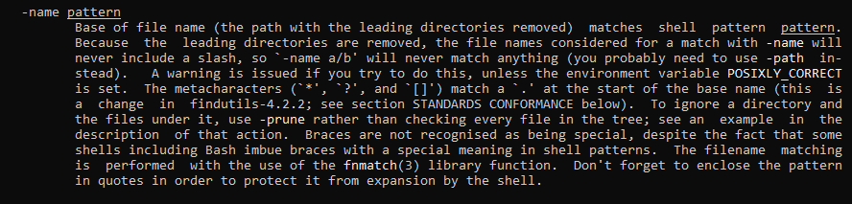
Example:
2)
Example:
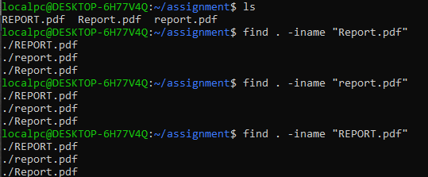
3)
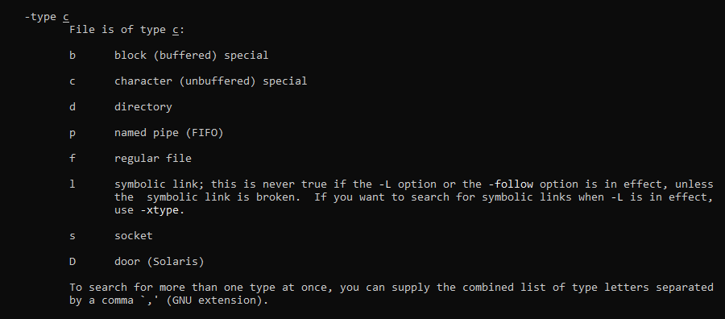
Example:
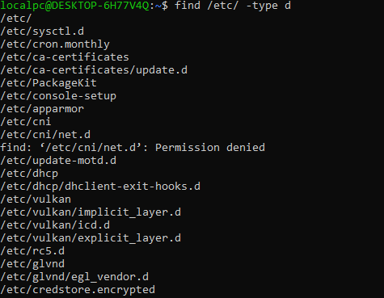
4)
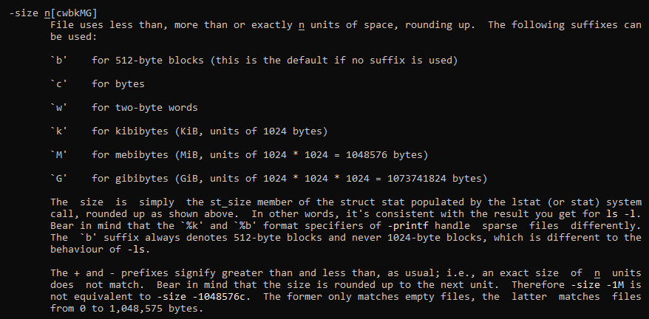
Example:
5)
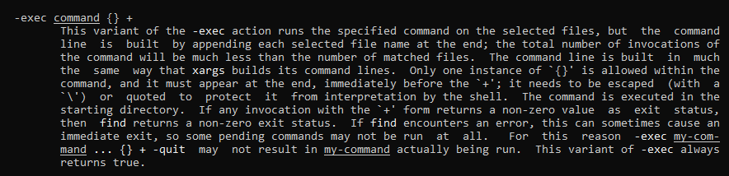
Example:
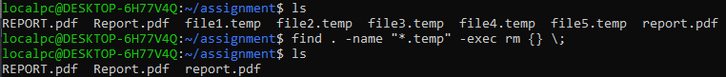
2. Create a directory structure containing multiple subdirectories and files. Use the mv command to move a file into another directory, rename a file, and move multiple files using a single command. Show the results of each operation.
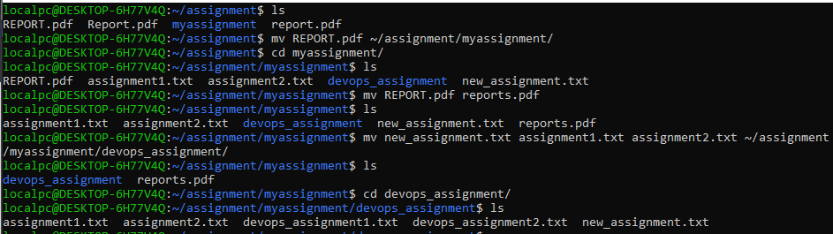

3. Use the history command to display your command history. Find a previously executed command and rerun it using its history number. Explain how you identified the command.
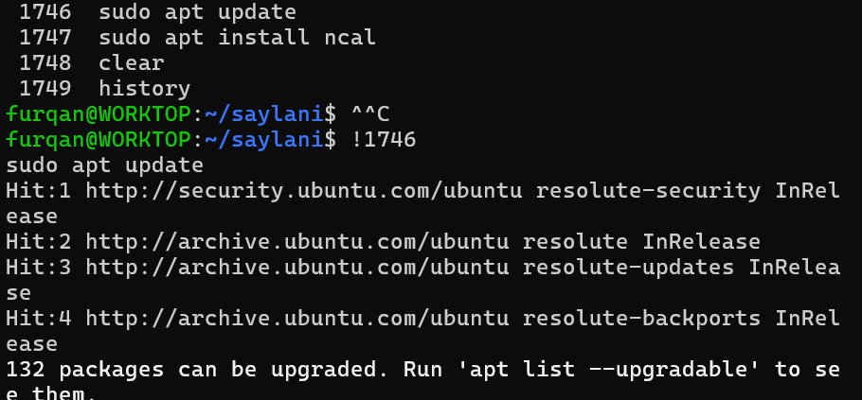

4. Use the locate command to search for a file by name. If the search does not return the expected result, investigate whether the locate database needs updating. Show the commands and outputs. (If locate or updatedb is unavailable, mention this in your submission.)
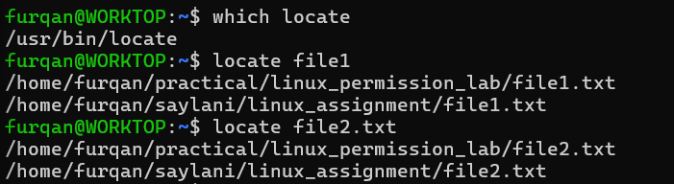

5. Use the find command to search for all .log files inside your home directory. Then find files modified within the last 24 hours and files larger than 1 MB. Share the commands and outputs.
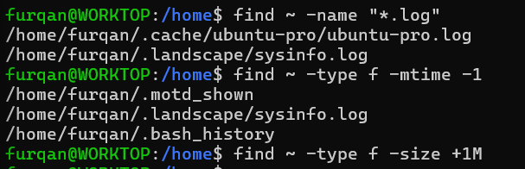

6. Use the help command to display the help information for three Bash built-in commands. Compare the output with the information provided by the man command for one of those commands.
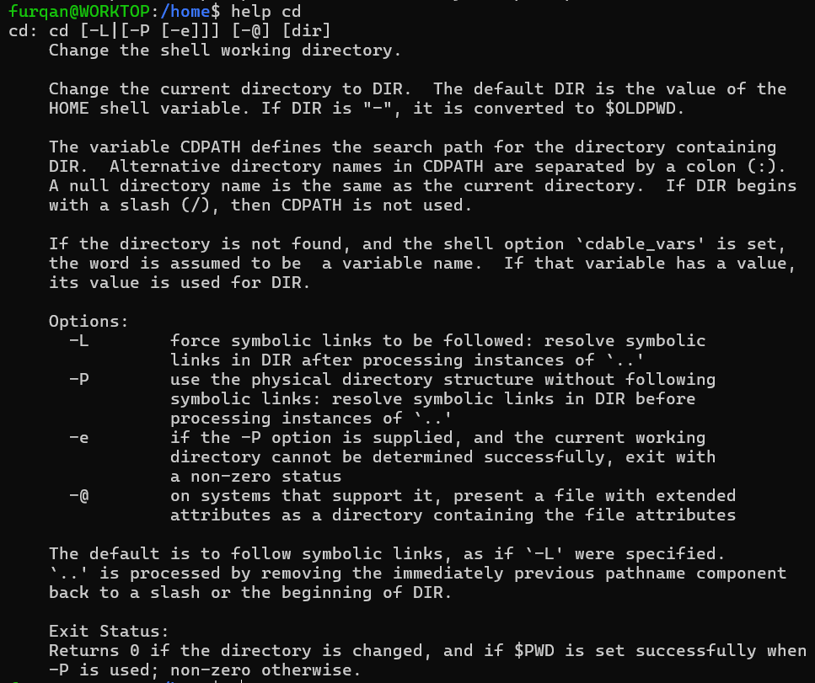
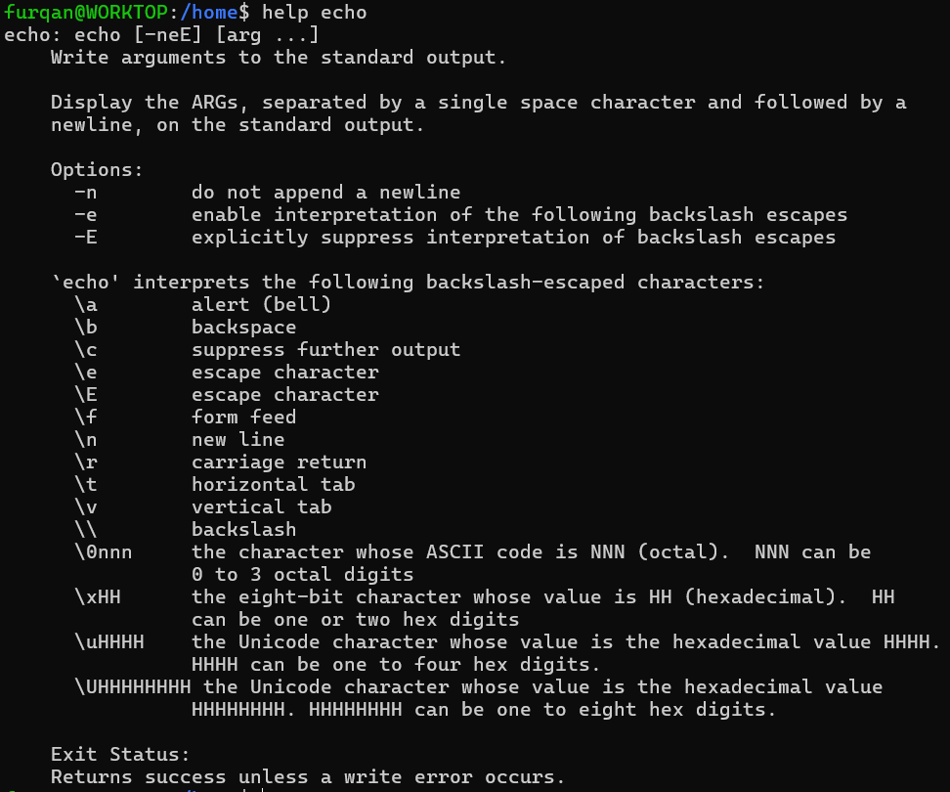
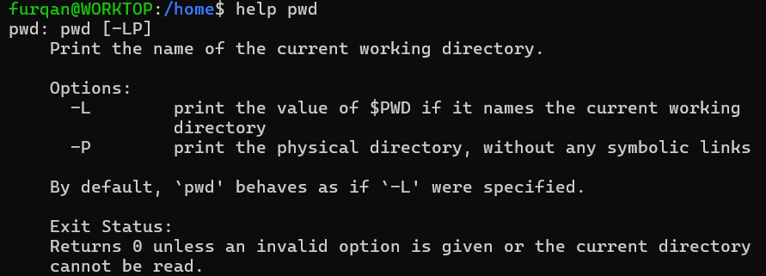
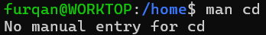
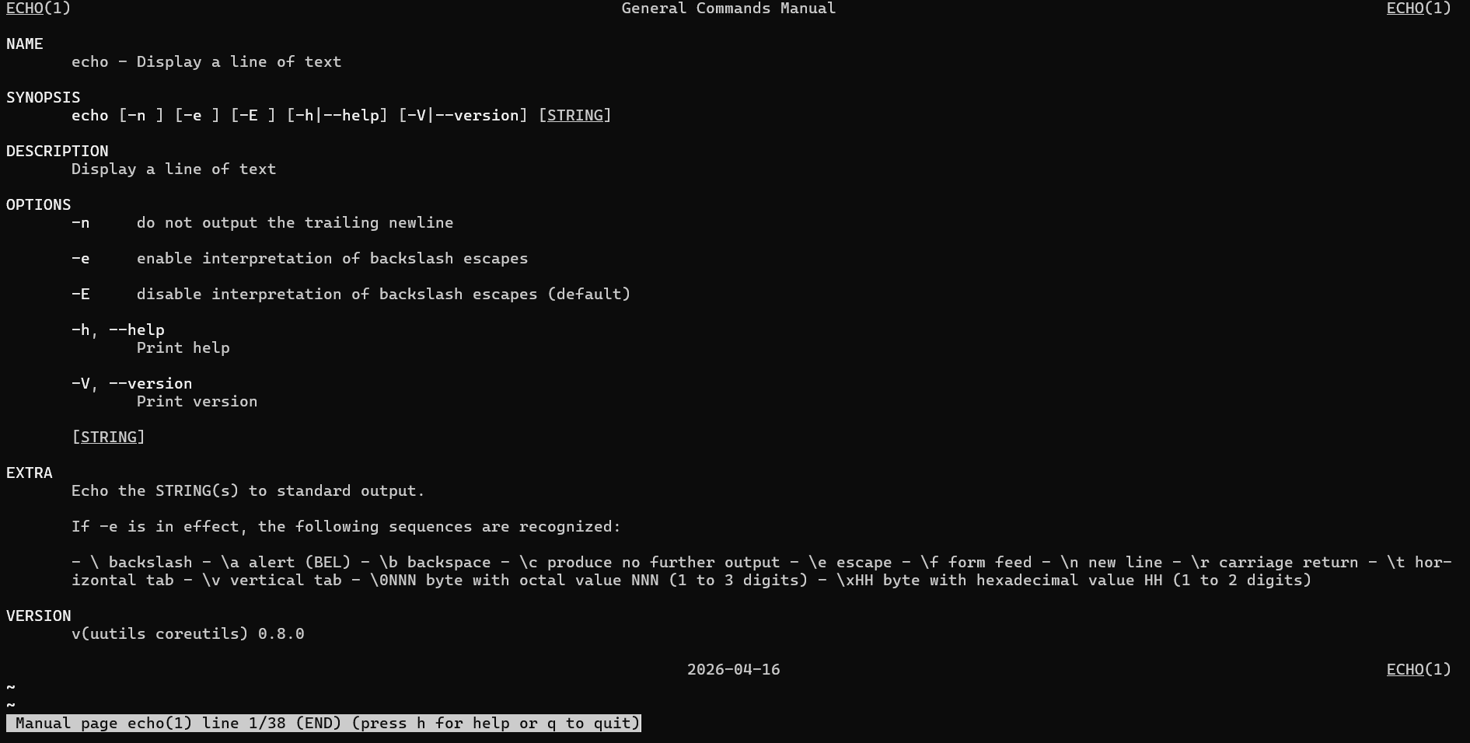
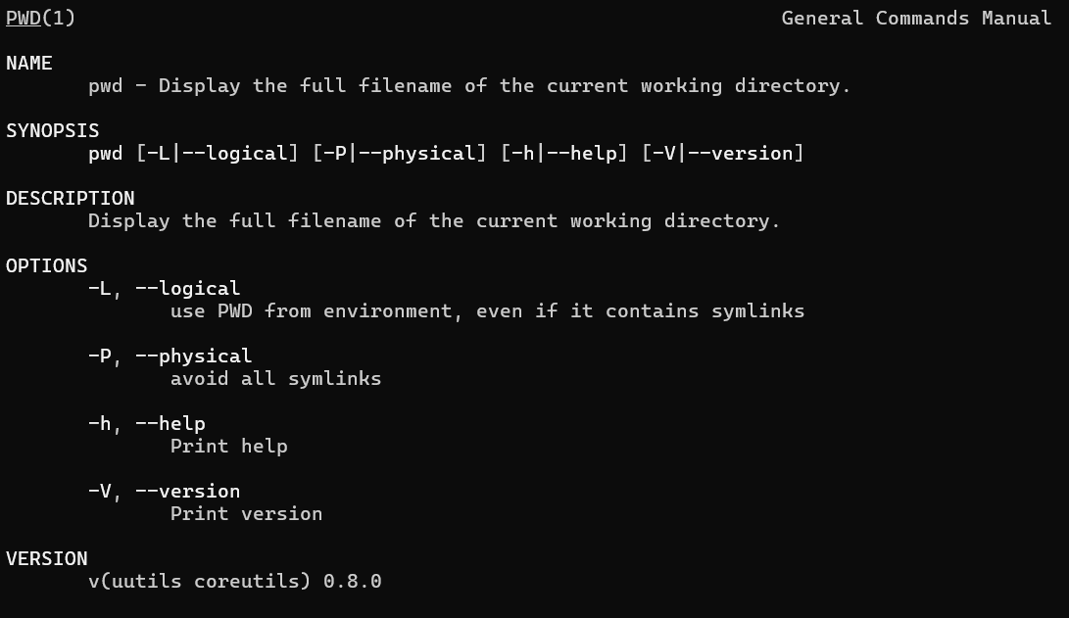
help pwd is Bash‑specific and describes the version active inside your shell — this is what actually runs when you type pwd at the prompt.
man pwd describes the independent command — useful when you call /usr/bin/pwd explicitly, but may not match every detail of the built‑in version.
7. Use the which, type, and whatis commands to investigate ls, cd, sudo, and find. Record their outputs and explain the differences between command location, command type, and short command descriptions.
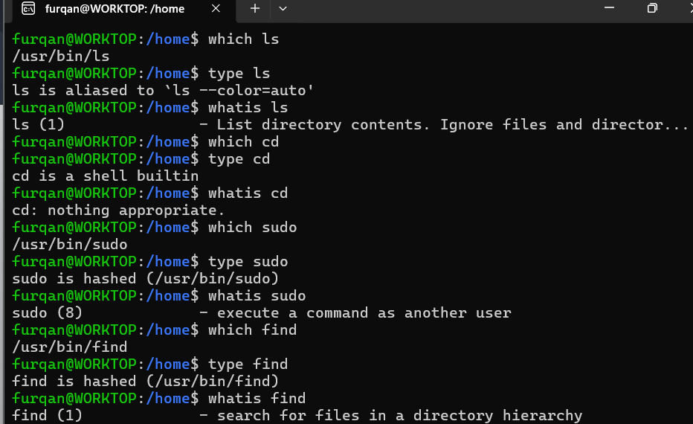
The command location shows the $PATH of the command executable file. The command type shows whether it is a builtin command inside shell or it is a external executable file . The whatis shows the short description about the command from the manual.

8. Use df -h to identify the filesystem with the most available space. Then use du -sh to check the size of your home directory and du -h --max-depth=1 ~ to compare the sizes of its immediate subdirectories. Explain the difference between the results.

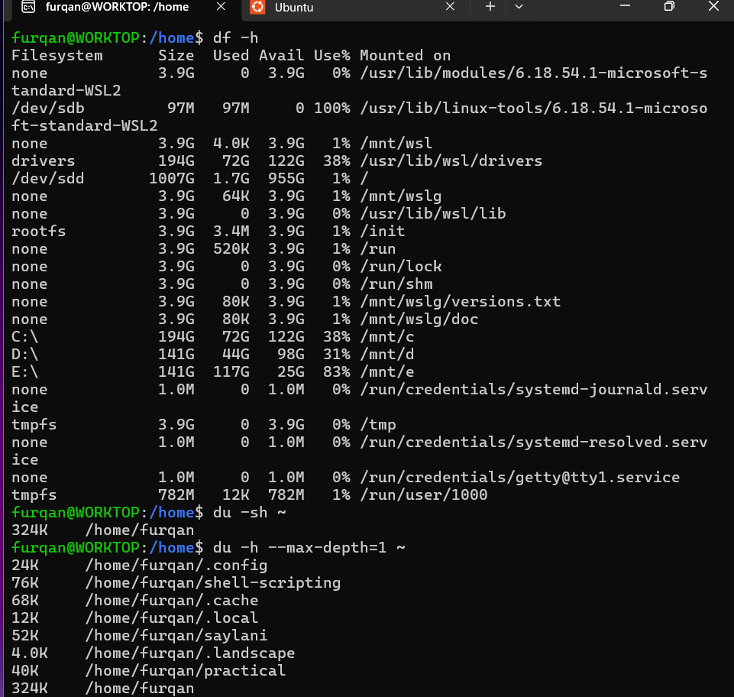
df -h See all disk partitions & free space
du -sh ~ Total size of home folder
du -sh ~ Top‑level subdirectory sizes
9. Use sudo to perform an administrative task, such as creating a directory under /opt named linux_assignment. Verify that it was created. Then explain why administrative privileges are required for this task. Do not modify system files unnecessarily.
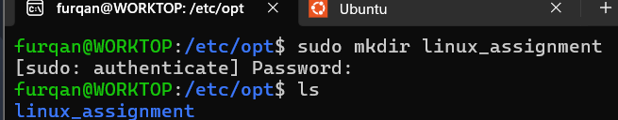
Administrative privileges are required to create changes in /etc/opt because it is system wide configuration directory owned by root user to avoid system malfunction and to protect system security.
10. Create two text files named original.txt and updated.txt with similar but slightly different content. Use the diff command to compare them. Then demonstrate the difference between normal output and unified output using diff -u.
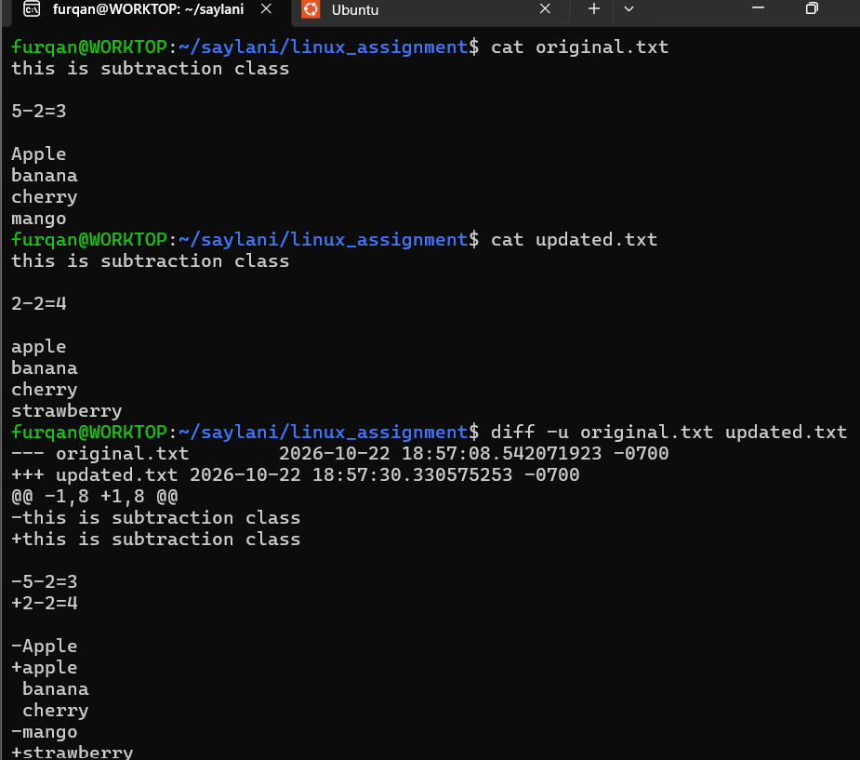
11. Create a file named permissions.txt. Use chmod with both symbolic and numeric modes to set its permissions to rw-r-----. Verify the final permissions using ls -l and explain what the permissions mean for the owner, group, and others.
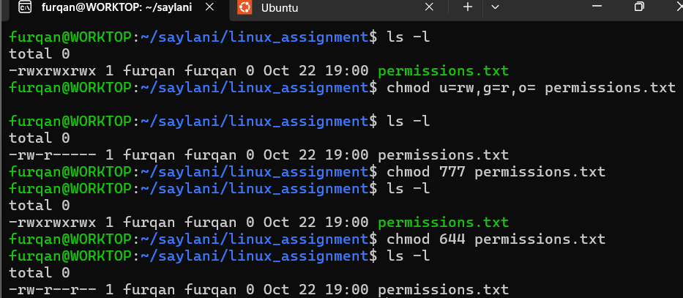
The permission u=rw or “6” means user has read and write access while g=r or “4” means group has only read access while o= or “0” means others have no access
12. Create a directory named team_project and a file inside it. Use chmod to assign appropriate permissions to the directory and file so the owner has full access, the group can read the file, and others have no access. Verify and explain your settings.
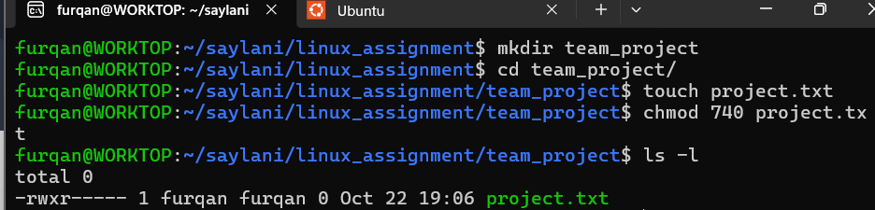
The permission “740” means user has read-write-execute access while group has only read access while others have no access
13. Use sudo chown to change the ownership of a test file to another existing user on your system. Verify the change using ls -l. If another user is unavailable, explain the prerequisite rather than changing ownership of an important system file.
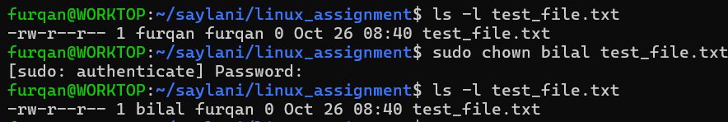

14. Create a directory containing at least five files with different extensions, such as .txt, .log, and .conf. Use find with appropriate conditions to locate files matching two criteria, such as files larger than a specified size and files modified within the last seven days. Display the results and explain your search conditions.
NOTE : Files were created already 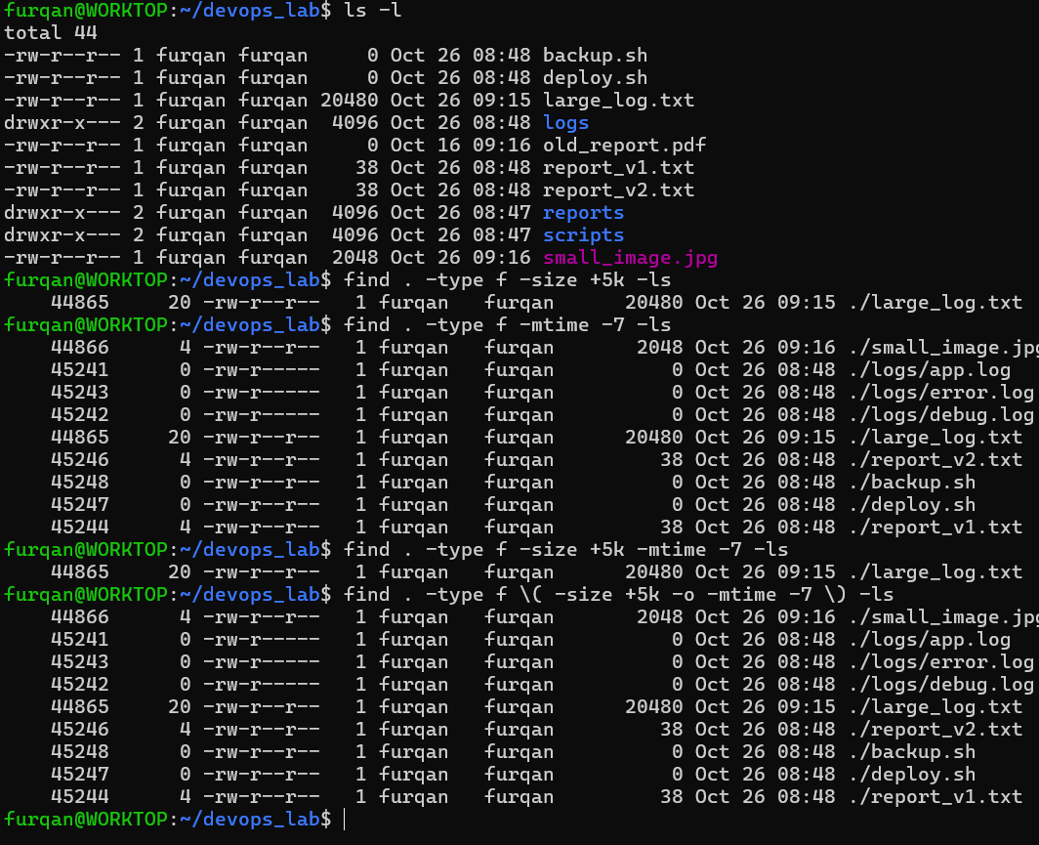
15. Practical challenge: Create a directory named devops_lab containing logs, reports, and scripts subdirectories. Create sample files, move the log files into logs, compare two report files using diff, locate all .log files using find, check the directory's disk usage using du, and configure suitable permissions using chmod and chown. Use sudo only when necessary. Submit screenshots showing the commands and their outputs at each stage.
